Name of the Student: G .Manasa | Academic Year: 2024-25
Student Registration Number: 241U1R3007 | Year & Term: II&I
Study Level: UG | Class & Section: CSE-DS-2A
Name of the Course: Python Programming | Name of the Instructor: Mr. V. Pranay Sir
Name of the Assessment: Group Assignment | Date of Submission: 12-08-2025
Group Assignment

- Write a program to input a string and perform slicing operations.
Input:
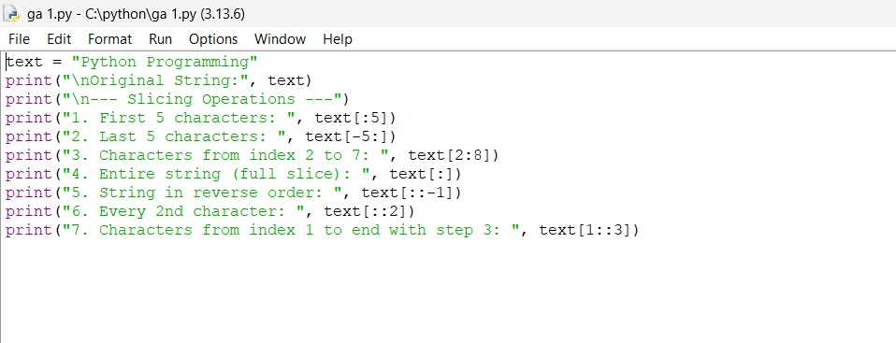

Output:
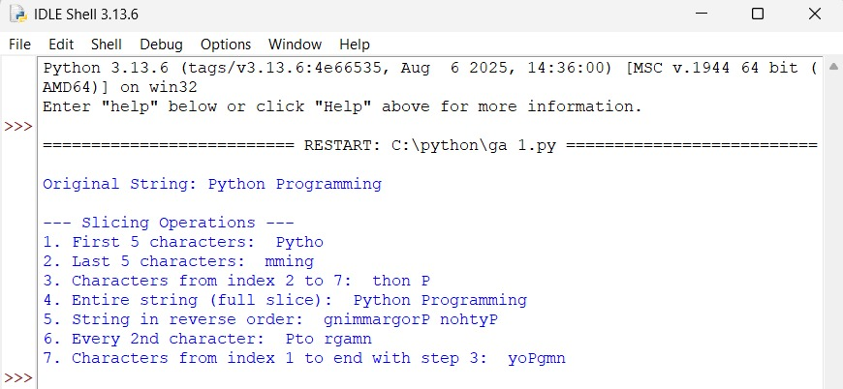

- Count characters, words, and lines in a given text file.
Input:
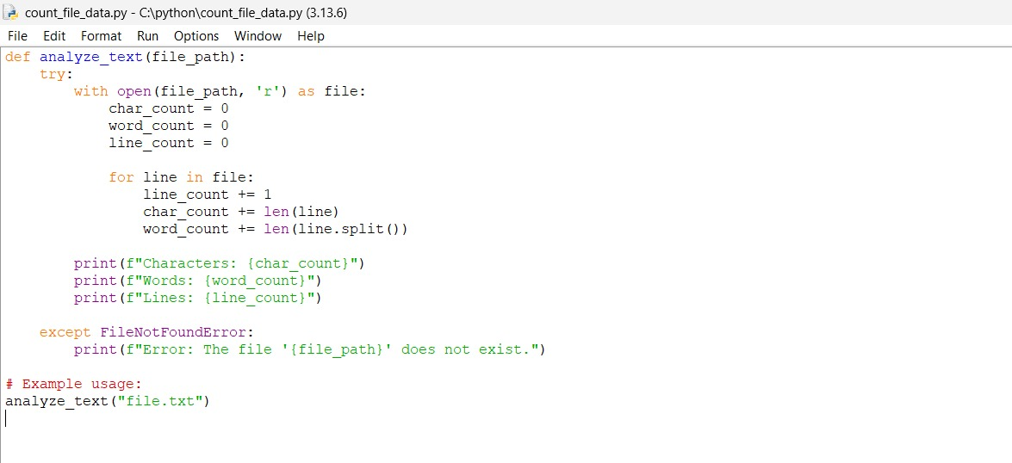

Output:
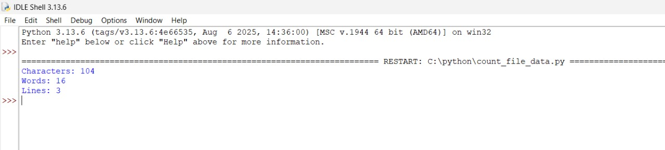

- Create a thread to print even numbers and another for odd numbers using threading module.
Input:
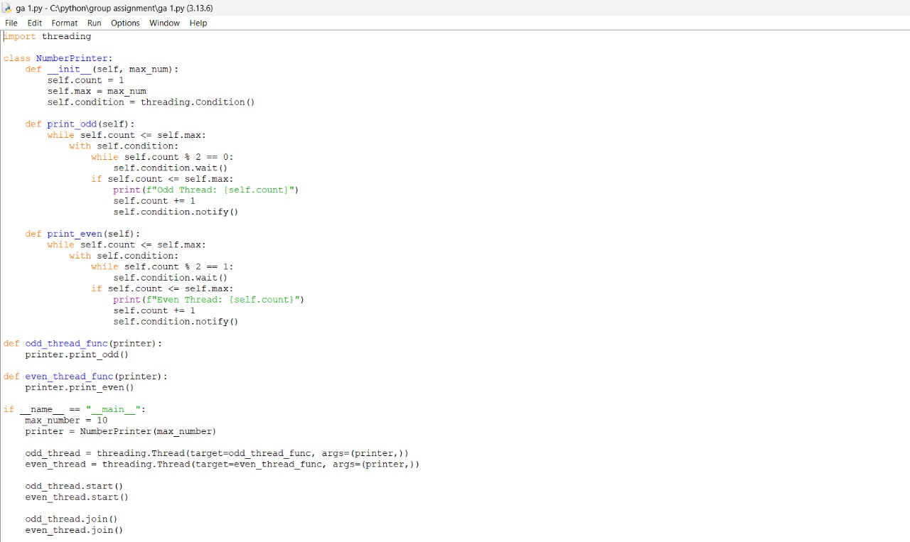

Output:
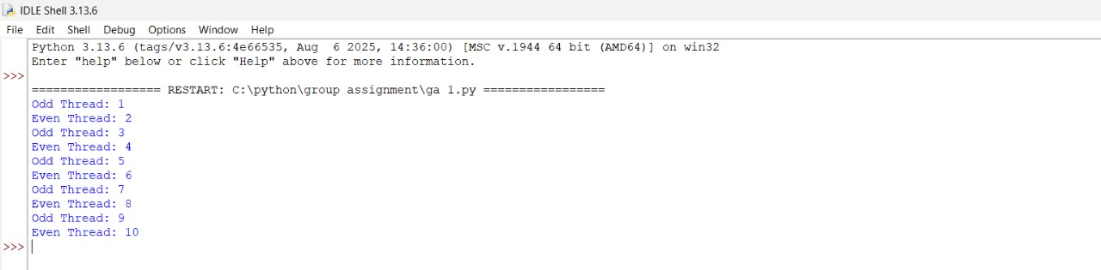

- Write a program to read content from two files and merge into a third file.
Input:
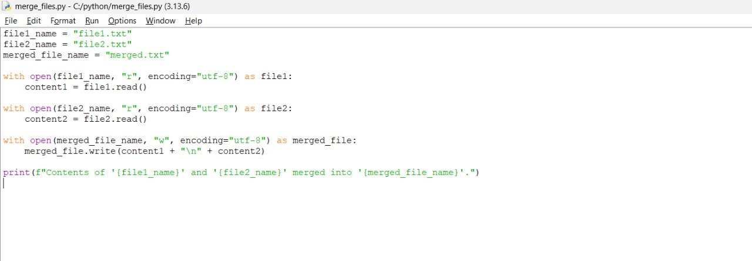

Output:
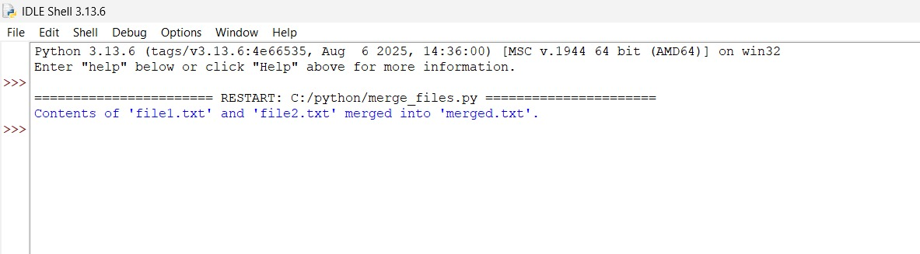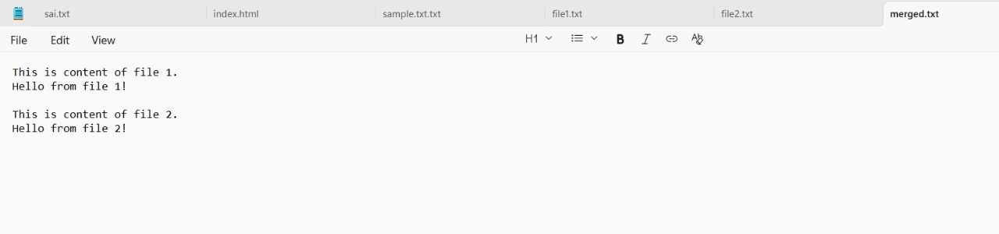

- Design a class Student with name and marks, inherit it in class Result and display grade.
Input:
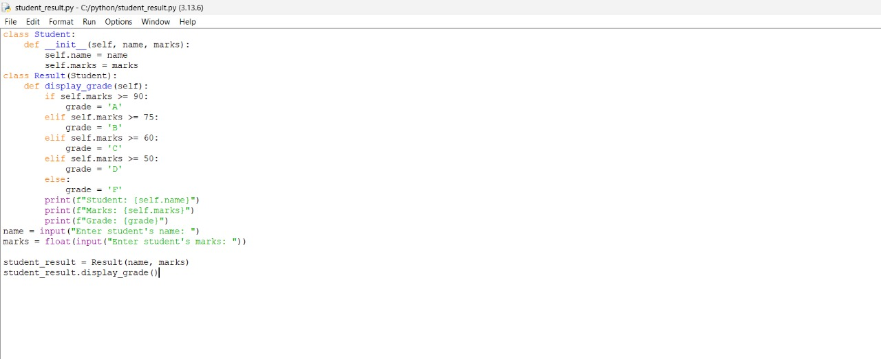
Output:
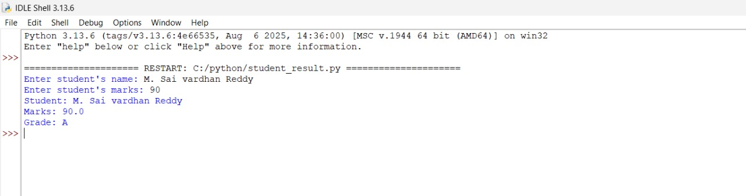

- Write a program to perform union, intersection, and difference on sets.
Input:
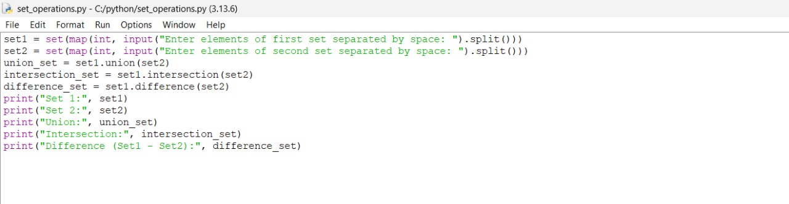

Output:
